Almaco Non-Stop
Wiring
Red and White wires should be placed in the “A” position of the weather-pack connector and Black wires should be placed in the B position.
Configure weather-pack connectors so the male pins are used in the male housing and the female pins are used in the female housing.
On the header, place a male connector on the “Clutch” cable and place a female connector on the “Brake” cable.
Attach the corresponding connectors to the actuator cables ran down from the HM module. Clutch will be in Act 3 (H2 = Aux 2-7) and Brake will be in Act 4 (H2 = 2-8) on second Actuator module.
Red wires connect to White wires between cables.
Black wires connect to Black wires between cables.
Set Actuator 7 (H2 = Aux 2-7) and 8 (H2 = Aux 2-8) in Mirus software to “GG Pneumatic” with “NO” limit switches
Set the “Head Control Actuator” to 0, this will not be used on an Almaco
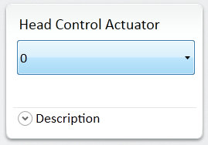
Set the “Clutch Control Actuator” to 7. This will control the clutch on the header
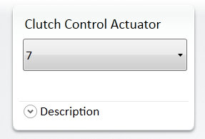
Set the “Brake Control Actuator” to 8. This will control the brake on the header
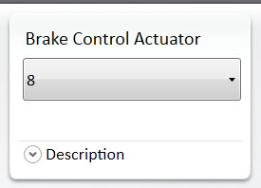
Combine / System Operation with Almaco Non-Stop
Non-Stop combine driving speed will be 0.7-1.4 mph
- Push Cycle button in Mirus to start system. Countdown timer will be started, typical settings will be 10-14 seconds.
- Mirus will wait the time set in “Start Delay” in software, typically 1000-3000 miliseconds.
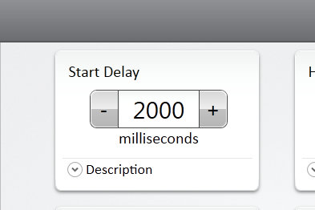
- Actuator 7 will then “Open” to Disengage the header clutch
- Mirus will wait the time set in “Brake Enable Delay” in software, typical setting 500-800ms
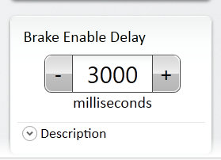
- Actuator 8 will “Close” to apply the brake
- Mirus will wait the time set in “ Isolation Delay” in software, typical setting 8000-12000, this delay will need to be shorter than the “Countdown” timer
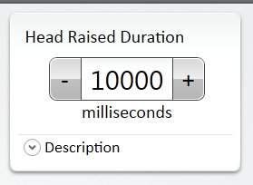
After time has expired from “Isolation Delay”
- Actuator 8 will “Open” to Disengage the Brake
- Mirus will wait the time set in “Clutch Enable Delay” in software, typical setting 500-800ms
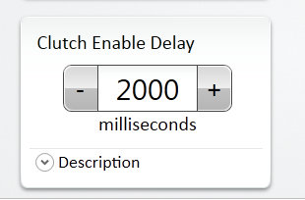
- Actuator 7 will “Close” to engage the header clutch
Gotcha’s
- When testing to make sure you have the brake and clutch in the right actuator position, you should be able to manually actuate the solenoid and hear and/or feel the brake and clutch engage/disengage. However, I found a couple of times this year that this didn’t work, as I got no response from either. Both the clutch/and brake were stuck from sitting. Before testing, engage the head for 10-15 seconds and this will free everything up if it is stuck.
- Cannot glean open a field without the Toughpad and Mirus opened up, as the clutch will be disengaged when you close Mirus and power down the system controller.
- On Almaco CR with air delivery, you will need to wire in the air diverter to the cyclone to be controlled by Mirus.

Syngenta Non-Stop
Wiring
- Connect black to black and red to whatever color is left. Solenoid is located middle, top, front, of throat. Only 1 weather-pack will be needed on this machine.
Set “Head Actuator Control” to 5, this will control raising and lowering the cross auger.
Set “Brake and Clutch Control Actuators” to 0, they will not be used on Syngenta system.
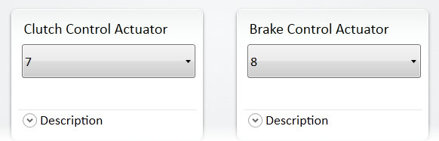

Combine / System Operation with Syngenta Non-Stop
Combine speed will be 0.7-1.4 mph
- Push Cycle button in Mirus to start the “Countdown” timer. Typical setting 10-14 seconds
- Mirus will wait the time set in “Start Delay” in software, 1000-1500 ms
- Actuator “5” will “Open” and raise the cross auger in the header
- Mirus will wait the time set in “Isolation Delay” in software, 6000-8000 ms, needs to be shorter than countdown timer
After time has expired from “Isolation Delay”
- Actuator “5” will “Close” and lower the cross auger in the header.
Gotcha’s
- Make sure when setting up Syngenta machine, Set the “Clutch Enable Delay” and “Brake Enable Delay” to “0”. If you time in these boxes it will get read by the software and ad cycle time to the system even though they aren’t being used on the Syngenta setup.

