Zurn H2C Conditional Actions
June2021
On a Zurn machine, the H2C will divert the air flow from the cyclone prior to closing the isolation gate then divert the air back so that the grain from the next plot will go into the cyclone. In some cases, the operator may also want to bring a grain sample into the cab.
Air Diverter Actions
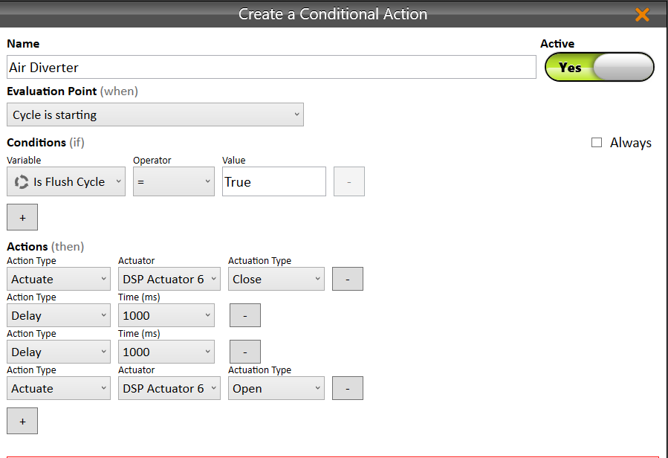
The air divertor is connected to DSP Actuator 6. Closing this actuator diverts the air to the tank away from the cyclone. This action only is needed on the flush cycle. Having it on the every cycle will result in grain being sent to the tank if strip mode has been invoked. The delay can be adjusted based on amount of grain swirling in the cyclone. After delay expires, Iso Gate closes and H2 Cycle starts.
WARNING: Customers need to be trained to ensure their plot to plot sequencing does not allow grain to be harvested while air is diverted to the grain tank!!
To ensure the air is diverted to the cyclone when entering collection mode, be sure to add a command to the “CollectionSetup.py” script to OPEN actuater 6 (see below).
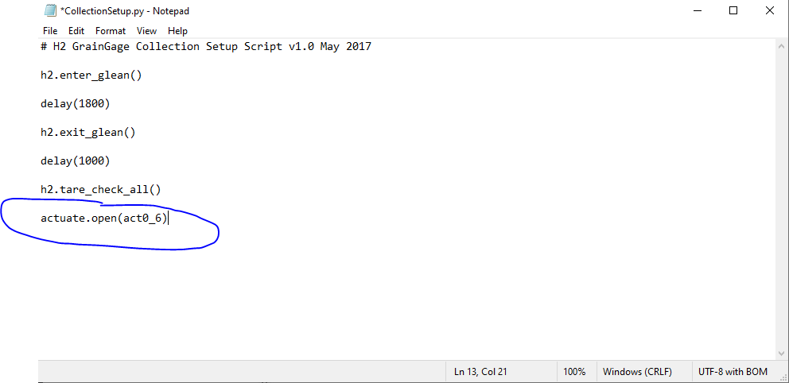

Sample Action – Most operators typically only use the button in the cab to trip the sampler so this conditional action normally is not needed
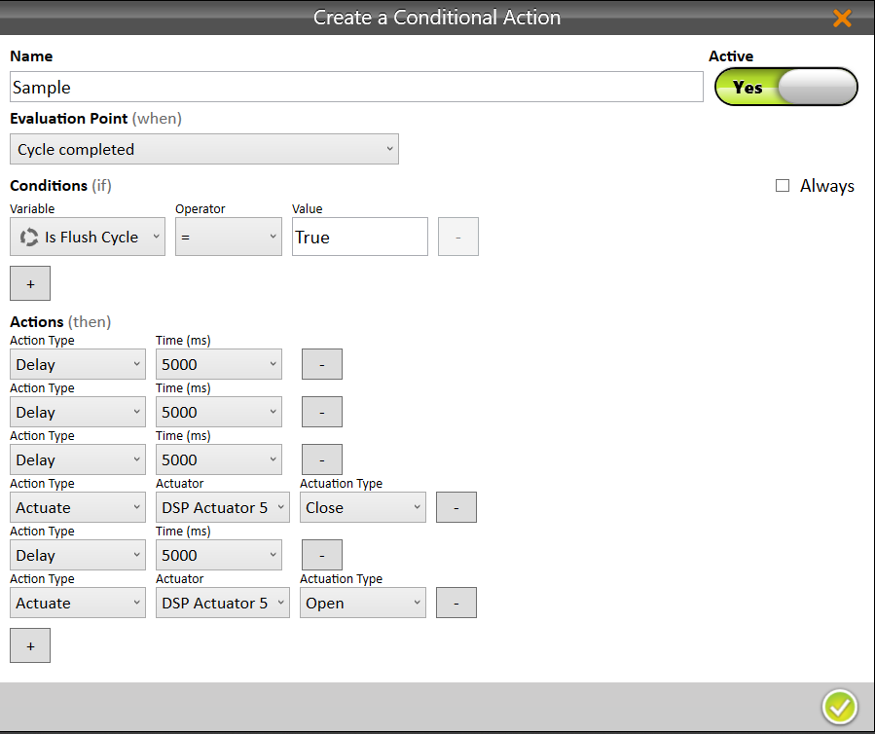
Sample system is connected to DSP Actuator 5. Close opens a gate inside the cab letting the grain fall into a bag. The delay before closing DSP 5 is the time it takes a sample to get from the bottom of the GG into the cab. The delay time could be reduced with smaller samples. The 5 second delay after closing DSP 5 is to allow large grain samples to drop into the bag. This can also be reduced. After the 5 second delay, DSP 5 needs to be opened. This command is not shown in the screen capture.

